CSE 251A: Machine learning Winter 2021

Programming project 2 — Coordinate Descent

Name: Xuanyu Chen

PID: A53306915

1. **Description**

Coordinate descent is a simple and useful approach to solve an unconstrained optimization problem. Coordinate descent algorithms solve optimization problems by successively performing approximate minimization along coordinate directions. If

$f$ is a k-dimensional function, we can minimize $f$ by successively minimizing each of the individual dimensions of $f$ while holding the values of $f$ in the other dimensions fixed. The primary advantage of this approach is that it takes an arbitrarily complex k-dimensional problem and reduces it to a collection of k one-dimensional problems.

1. **Pseudocode**

**Algorithm 1** Coordinate Descent

1. **Input**:

$α$: a positive constant, the step-size for every update in one coordinate

$θ$: threshold

N: maximum number of iterations

F: bool, if False means the loss value is not optimal, True means optimal

1. **Output**: vector $w$ and optimal loss value $f\left(w^{t}\right)$
2. **Procedure** COORDINATEDESCENT
3. set $t←0$ and choose $w^{0}∈ R^{d}$
$loss← f\left(w^{0}\right)$

5. **while $(F == False) \& (t < N)$** :
6. choose index $i_{t}∈ \left\{1, 2,…,d\right\}$ which is ${argmax}_{i_{t}}abs({\left[∇f\left(w^{t}\right)\right]}_{i_{t}})$
$I.append(i_{t})$

8. $w^{t+1}← w^{t}- α{\left[∇f\left(w^{t}\right)\right]}_{i_{t}}$;
$newloss← f\left(w^{t+1}\right)$

10. **while $(loss - newloss) <θ$** *:*
11. choose index $i_{t}∈ \left\{1, 2,…,d\right\} \&{ i}_{t}∉I$ which is ${argmax}_{i_{t}}abs({\left[∇f\left(w^{t}\right)\right]}_{i_{t}})$
$I.append(i_{t})$

13. $w^{t+1}← w^{t}- α_{t}{\left[∇f\left(w^{t}\right)\right]}_{i_{t}}$;
$newloss← f\left(w^{t+1}\right)$

15. **if $len\left(I\right)==len(w)$** :
$F←True$

17. **break**
$loss←newloss$

19. $t← t+1$*;*
20. **Experimental results**

The optimal log-loss calculated based on the LogisticRegression function (with parameter C = 50) from scikit-learn package is 0.02102.

Here are the results calculated by my Coordinate Descent algorithm:

Table 1.

|  |  |  |  |  |  |
| --- | --- | --- | --- | --- | --- |
| Max-Iteration | 500 | 1500 | 5000 | 7000 | 9000 |
| alpha | 0.1 | 0.1 | 0.1 | 0.1 | 0.1 |
| threshold | 1e-3 | 1e-4 | 1e-5 | 1e-6 | 1e-6 |
| Log-loss | 0.475 | 0.158 | 0.0589 | 0.048 | 0.0386 |
| iterations | 403 | 1500 | 4622 | 7000 | 9000 |

Figure 1. (First 100 iterations)

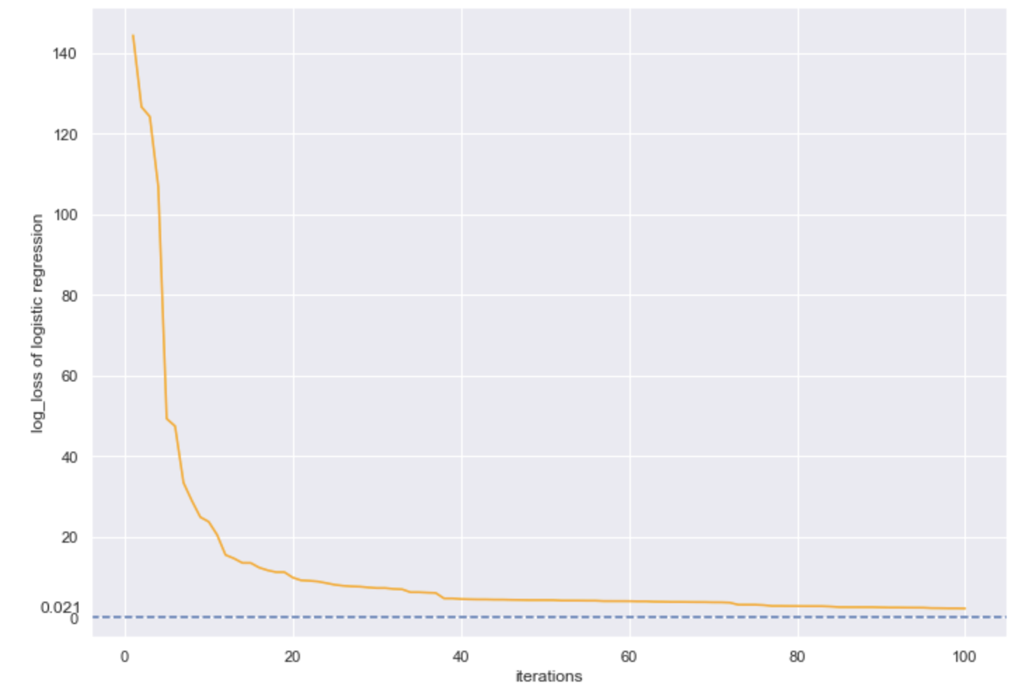

Figure 2. (Last 500 iterations)

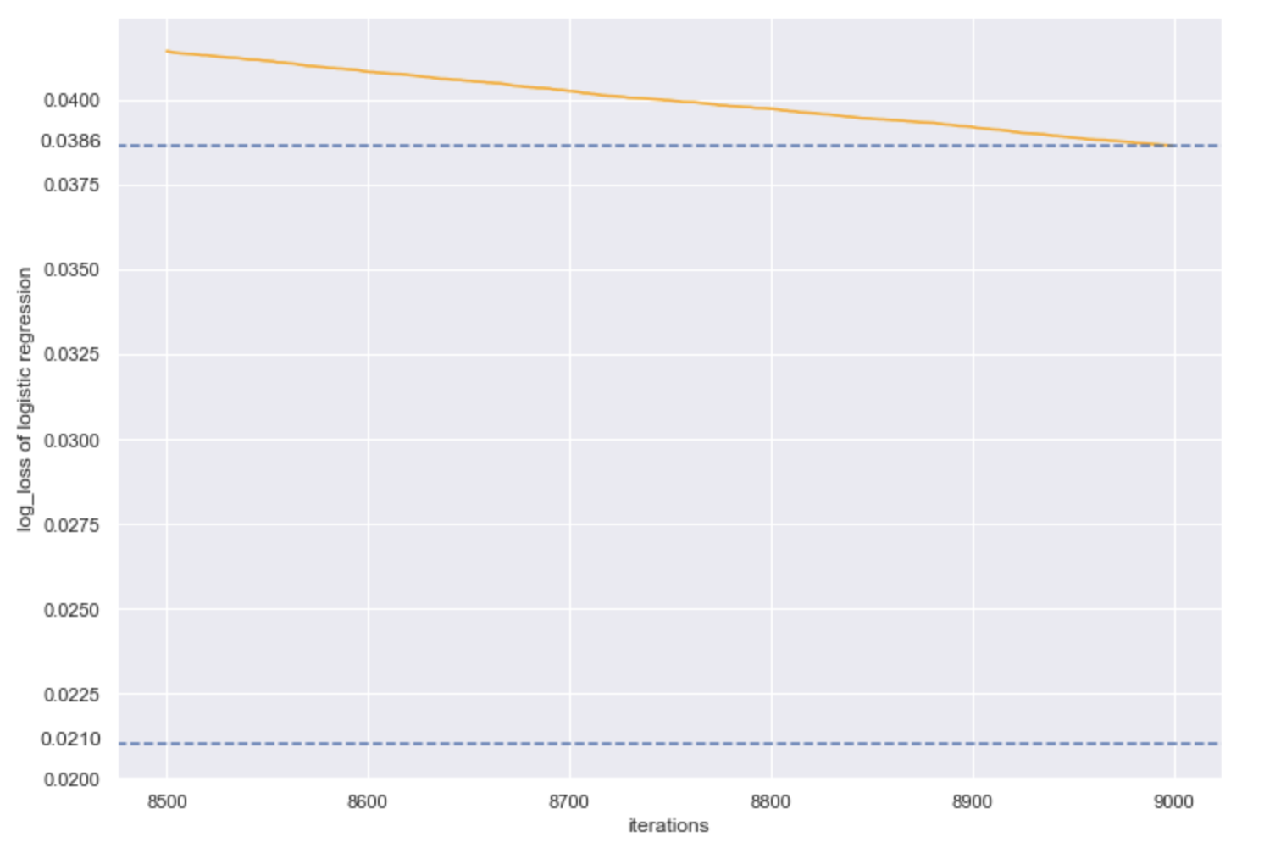

1. **Critical evaluation**
2. In my Coordinate Descent algorithm, I choose the index of coordinate which maximizes the first derivative of function $f$. I also tried to use the method of choosing the index of coordinate randomly. It turns out that the difference between these two methods is not such big like I imagined before. In the future, I may try to use other smarter method to select the coordinate index so that $L(w^{t})$ can approach to $L^{*}$ more quickly and better.
3. Through my experiment, the “initial starting point” and the original data influence my algorithm a lot. If I use a vector containing all zeros as my initial weight, then it turns out that my final outcome is pretty bad. Moreover, I use MinMaxScaler() function to standardize the original data so that $L(w^{t})$ can approach to $L^{*}$ better.
4. For every coordinate-dimension update, my step size is constant. Intuitively, the update step size will decrease as iteration goes on. I have read a paper about *Adam Optimization Algorithm* before and it inspired me that my future improvements could include updating step size in real time.